Loki Kit User Manual

**V1.1**

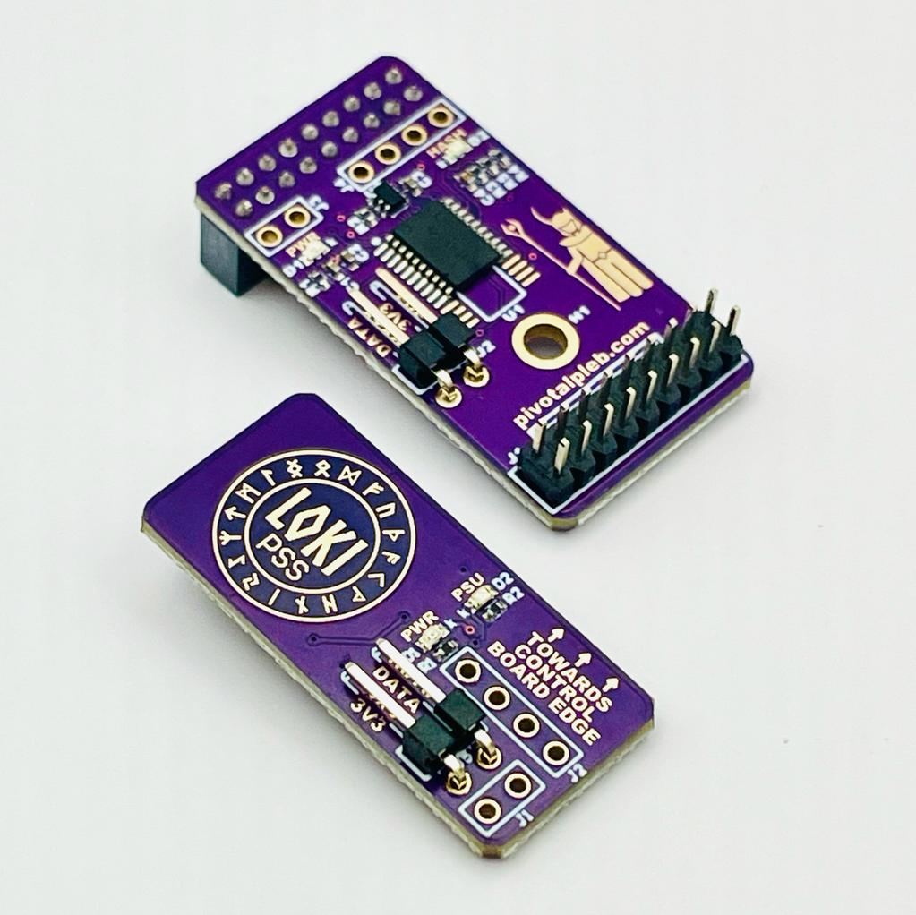

**Table of Contents**

**Warnings and Disclaimers 2**

**Product Overview 3**

**Expanded Kit Components 4**

**Loki Kit Variants 5**

**Installation Instructions 7**

Required Tools for Installation 7

Installation Steps 7

Step 1 7

Step 2 8

Step 3 8

Step 4 8

Step 5 8

Step 6 9

Step 7 10

Step 8 14

Step 9 14

**Configuring LOKI-PSS 15**

**Selecting a Suitable Power Source 16**

Electrical DC Current Draw and Resulting Power Requirements 16

Powering the Miner’s Control Board 16

High Current Hash Board Conductors 16

Copper Conductor Ampacity Chart 17

Aluminum Conductor Ampacity Chart 18

**Hashing from 120V AC 19**

**Limiting Miner Power Draw 19**

Reducing Hash Voltage and Hash Frequency 19

Remove Hash Boards 20

**Hash Voltage, Hash Rate, and Miner Efficiency 20**

**Autotuning with LoKi 22**

**APPENDIX 22**

# 

# Warnings and Disclaimers



**CAUTION**: Using power supply spoofer equipment like the Loki Kit can cause electrical circuit overload resulting in flames and damaged equipment if not implemented properly. Read all installation instructions and ensure proper equipment configurations before attempting to power any mining equipment from alternative power sources.



**CAUTION**: Using power supply spoofer equipment like the Loki kit can increase the risk of overheating and damaging your miner if not implemented properly. It is advised to monitor system temperatures closely to ensure they stay within safe limits.



**WARNING:** Installing the Loki kit on your miner may void the miner’s warranty. It is recommended to thoroughly research and evaluate the potential risks and benefits of using the Loki kit before installing it on your mining rig.

# 

# 

# 

# 

# 

# 

# 

# 

# 

# Product Overview

The Loki kit was designed to allow most miner variants in the Bitmain Antminer X19 (S19 and T19) family to run from any power source capable of supplying sufficient electrical current between 12-17V DC with minimal modifications to the miner.

Off-the-shelf Bitmain Antminers are sold with a power supply unit (PSU) that makes it possible and convenient to power the miner from the utility power grid. It converts high voltage AC power from the grid into low voltage DC power required by the miner to function properly. Technically, all miner components downstream of the PSU only require 12-17V DC to function properly; however, due to a firmware protocol executed by the miner’s control board (CB), the miner will only start hashing after it has detected the presence of the stock PSU and verified that it’s functioning properly. The Loki kit essentially tricks the CB into thinking that all PSU requirements have been met. This allows the miner to start hashing, so long as it is being powered from a power source delivering sufficient electrical current at 12-17V DC.

The Loki kit can enable numerous alternative power configurations. It is beyond the scope of this document to explain all possible configurations, but basic principles and guidelines for selecting an alternative power source are discussed. See the “Selecting a Suitable Power Source” section below for more details. Additionally, this document discusses key consideration when using the Loki kit to hash from 120V AC. See the “Hashing from 120V AC” section below for more details.

While most X19 hash boards can hash from any voltage between 12 and 15V DC (S18 x88 hash boards want 14-17V DC), hash results and efficiency will vary significantly based on hash voltage. See the “Hash Voltage, Hash Rate, and Miner Efficiency” section below for more details.

Please note that while the Loki kit was designed to fit all control board variants, installation results may vary depending on the miner’s [control board variant](https://braiins.com/blog/bitcoin-mining-control-board-variations) (Xilinx, Beagle Bone, Amlogic) and/or the firmware the miner’s control board is running. It’s beyond the scope of this document to enumerate all possible control board variants and firmware version combinations, but Pivotal Pleb Tech has compiled and maintains a public [spreadsheet of Loki Kit test results](https://docs.google.com/spreadsheets/d/e/2PACX-1vRbkqH88QSdnSYRslRia6PBxx0taW0Kwzp7PBc3VXrbFCIQwf3ByNqNJvA-s_JDTI8C3m2xb8LJxVZh/pubhtml) on various miner configs.

Finally, there are 3 different Loki Kit variants that are designed to cover the most common X19 miner configurations: Loki-Duo, Loki-Lite, and Loki-AmLite. See the “Expanded Kit Components” and “Loki Kit Variants” sections below for more details.

# Expanded Kit Components

**(For Reference in Installation Instructions Below)**

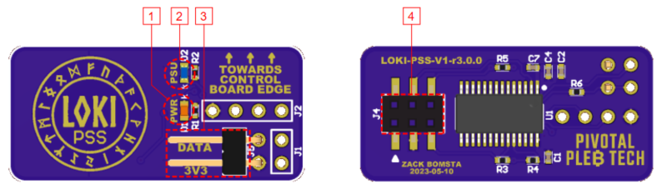

**LOKI-PSS Top View** **LOKI-PSS Bottom View**

1. LOKI-PSS Power Indicator LED 3. LOKI-PSS Power (3.3V) and Data Conn.

2. PSU Spoofed Indicator LED 4. Control Board Plug

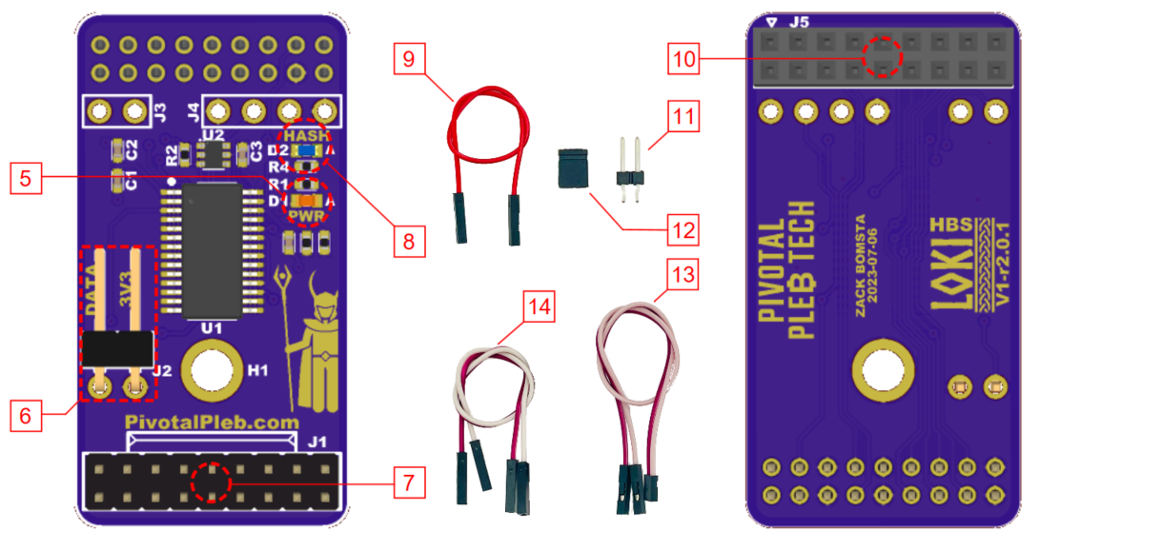

**LOKI-HBS Top View LOKI-HBS Bottom View**

5. LOKI-HBS Power Indicator LED 10. Control Board Ribbon Plug

6. LOKI-HBS Power (3.3V) & Data Conn. 11. 2-Pin Push-To-Install Header

7. Hash Board Ribbon Socket 12. 2-Pin Jumper

8. Hashing Indicator LED 13. 2-Wire 2mm-2.54mm Jumper (Any Color)

9. Single Wire Jumper (Any Color) 14. 2-Wire 2.54mm Jumper (Any Color)

The product components detailed above will be referenced throughout this document with the name followed by the corresponding number in square brackets [ ].

# Loki Kit Variants

The table below summarizes the three different Loki Kit variants: Loki-Duo, Loki-Lite, and Loki-AmLite.

The **Loki-Duo** variant is needed when running Braiins, Vnish, or Vnish derivatives like Asic.to firmware. This kit includes a power supply spoofer circuit board (LOKI-PSS), a hash board voltage spoofer circuit board (LOKI-HBS), a 2-Pin Push-To-Install Header [11], a 2-Pin Jumper [12], and a 2-Wire 2.54mm Jumper [14].

The **Loki-Lite** variant can be used when running Bitmain, LuxOS, or HiveOS firmware on a Xilinx or Beagle Bone control board. This kit includes a LOKI-PSS board, a 2-Pin Push-To-Install Header [11], a 2-Pin Jumper [12], and a 2-Wire 2mm-2.54mm Jumper [13].

The **Loki-AmLite** variant is designed to work with the Amlogic control board running standard, hash boards. It is not recommended to use the Loki-AmLite kit with “NoPic” hash boards running Bitmain firmware when powering from a standard 120V outlet. This is because Bitmain requires a “full chain” (3 working hash boards) and doesn’t allow significant underclocking. These two factors combined will result in the miner drawing more than 1500 W and overload the circuit. See the “Hashing from 120V AC” and “Limiting Miner Power Draw” sections below for more details. The Loki-AmLite Kit includes a LOKI-PSS board, two 2-Pin Push-To-Install Header [11], a 2-Pin Jumper [12], and a Single Wire Jumper[9].

| **Kit Variant** | **Firmware** | **Kit Components** | |
| --- | --- | --- | --- |
| **Loki-Duo** | Braiins, Vnish, or Vnish Derivative like Asic.to |  | * LOKI-PSS * LOKI-HBS * 2-Pin Push-To-Install Header [11] * 2-Pin Jumper [12] * 2-Wire 2.54mm Jumper [14] |
| **Loki-Lite** | Bitmain, LuxOS, HiveOS |  | * LOKI-PSS * 2-Pin Push-To-Install Header [11] * 2-Pin Jumper [12] * 2-Wire 2mm-2.54mm Jumper [13] |
| **Loki-AmLite** | Bitmain with Amlogic CB and Standard HB |  | * LOKI-PSS * Two 2-Pin Push-To-Install Header [11] * 2-Pin Jumper [12] * Single Wire Jumper [9] |

# 

# 

# Installation Instructions

The instructions in this section are for installing the Loki kit components onto a Bitmain Antminer X19 miner.

These instructions assume that a suitable DC power source has already been selected and appropriate connections have been made from the power supply to the hash board(s) and control board. See “Selecting a Suitable Power Source” for more details. These instructions also assume that proper measures have been taken to limit the total power draw of the miner from the 120V outlet to no more than 1500 W max. See the “Limiting Miner Power Draw” section below for more details.

## Required Tools for Installation

The following tools are recommended for installing the Loki Kit.

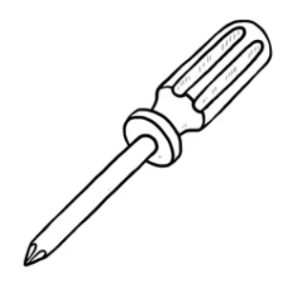

#1 Phillips Screwdriver

## 

## Installation Steps

Some installation steps below will vary based on which Loki Kit variant is being installed. The steps that vary will have individual variant labels. If no variant label is given, the installation step is common among all variants.

### 

### **Step 1**

Power down and unplug all mining equipment. DO NOT ATTEMPT TO INSTALL THE LOKI KIT WHILE MINING EQUIPMENT IS POWERED ON.

### 

### **Step 2**

Remove the miner’s top cover and locate the miner’s control board.

### 

### 

### **Step 3**

Unplug the PSU data cable (if present) from the control board’s PSU data cable socket.

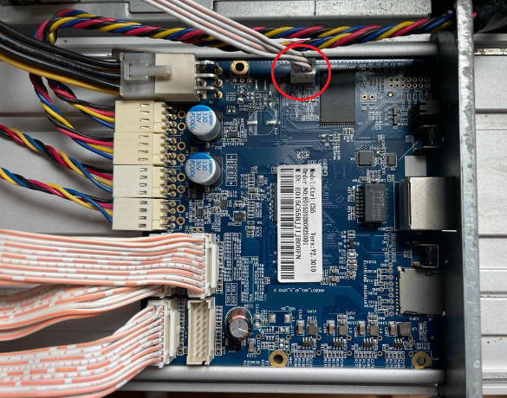 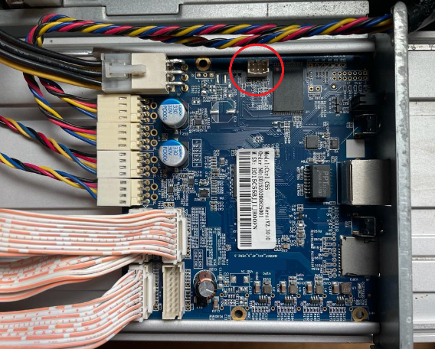

### 

### **Step 4**

Connect the LOKI-PSS board to the control board by plugging in the “Control Board Plug” [4] located on the back of the LOKI-PSS board into the PSU data cable socket. The “Control Board Plug” [4] should be facing down with the “LOKI-PSS Power Indicator LED” [1] facing up. Ensure that the arrows labeled “TOWARDS CONTROL BOARD EDGE” are facing the control board’s edge (see image below in step 7).

### 

### 

### **Step 5**

Fully remove any hash boards from the miner that won’t be hashing. This includes unplugging the hash board ribbon cable AND disconnecting the hash board’s power terminals from the power supply.

### 

### 

### 

### 

### **Step 6**

**Loki-Duo:** Unplug any remaining ribbon cables and plug the “Control Board Ribbon Plug” [10] located on the back of the LOKI-HBS board into one of the control board’s three ribbon cable sockets outlined in green in the image below. If the control board has four ribbon cable sockets, avoid connecting the LOKI-HBS board to the ribbon cable outlined in red below.

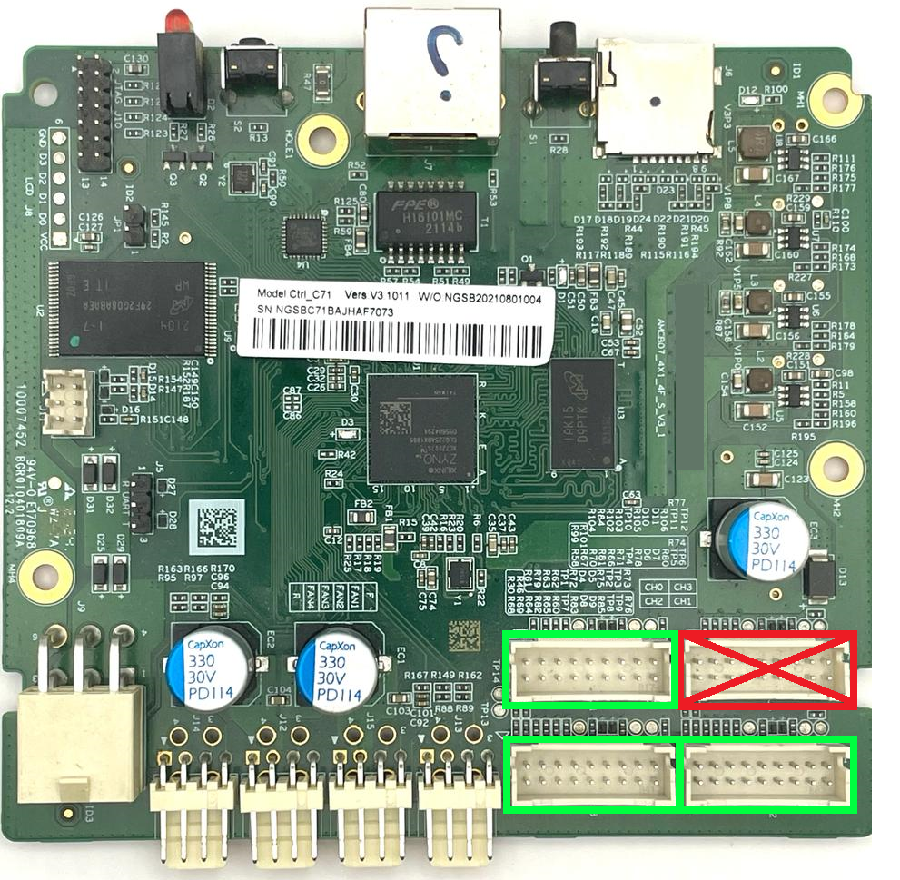 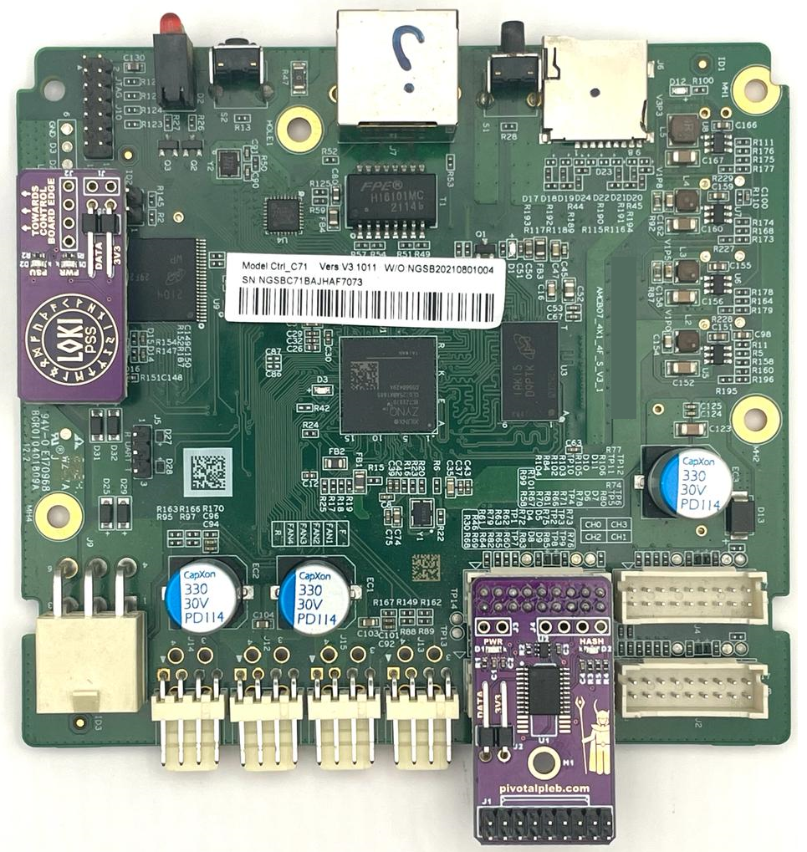

The “Control Board Ribbon Plug” [10] should be facing down with the “LOKI-HBS Power Indicator LED” [5] facing up and the “Hash Board Ribbon Socket” [7] extending out beyond the edge of the control board as shown in the image above.

**Loki-Lite:** Skip

**Loki-AmLite:** Skip

### 

### 

### 

### **Step 7**

**Loki-Duo:** Connect the LOKI-PSS board and the LOKI-HBS board with the “2-Wire 2.54mm Jumper (Any Color)” [14] by connecting the respective “DATA” and “3V3” pins between the “LOKI-PSS Power (3.3V) and Data Conn.” [3] and “ LOKI-HBS Power (3.3V) & Data Conn.” [6].

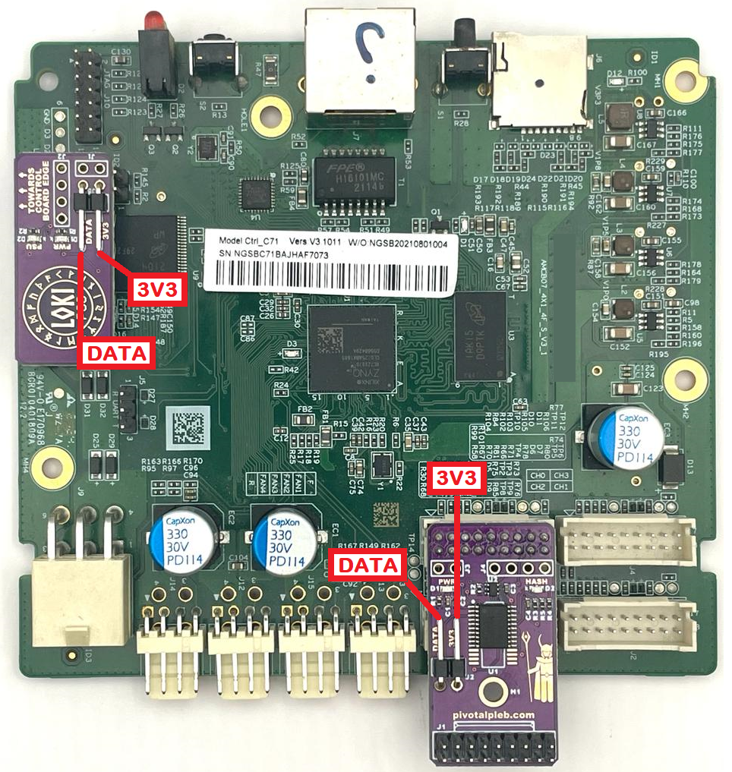

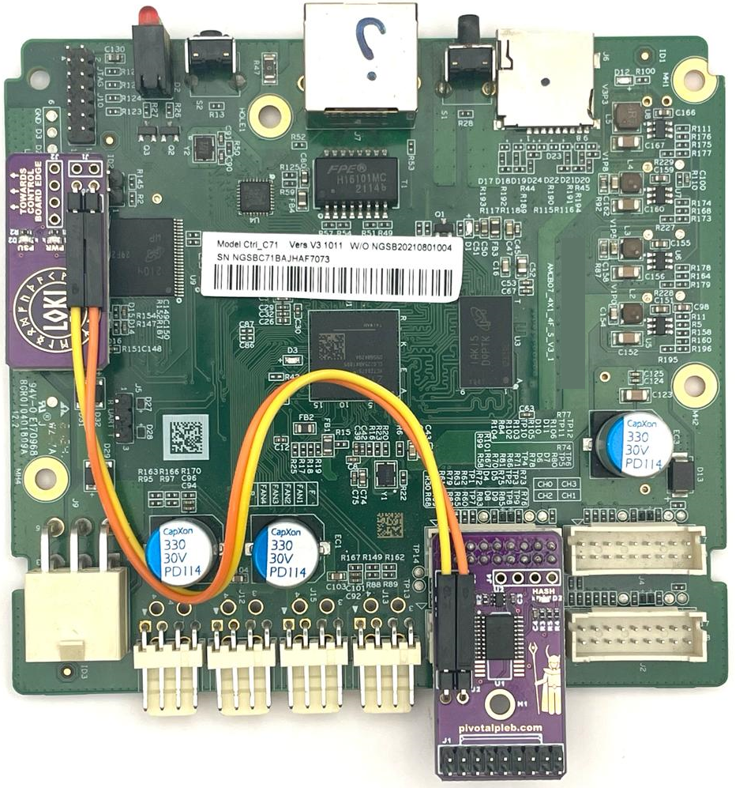

**Loki-Lite:** Connect the LOKI-PSS board to one of the control board’s unused ribbon cable sockets with the “2-Wire 2mm-2.54mm Jumper” [13] by connecting the “DATA” pin of “LOKI-PSS Power (3.3V) and Data Conn.” [3] to the bottom-right pin of the ribbon socket and the “3V3” pin of “LOKI-PSS Power (3.3V) and Data Conn.” [3] to the ribbon socket pin on the bottom row second from the right (see images below).

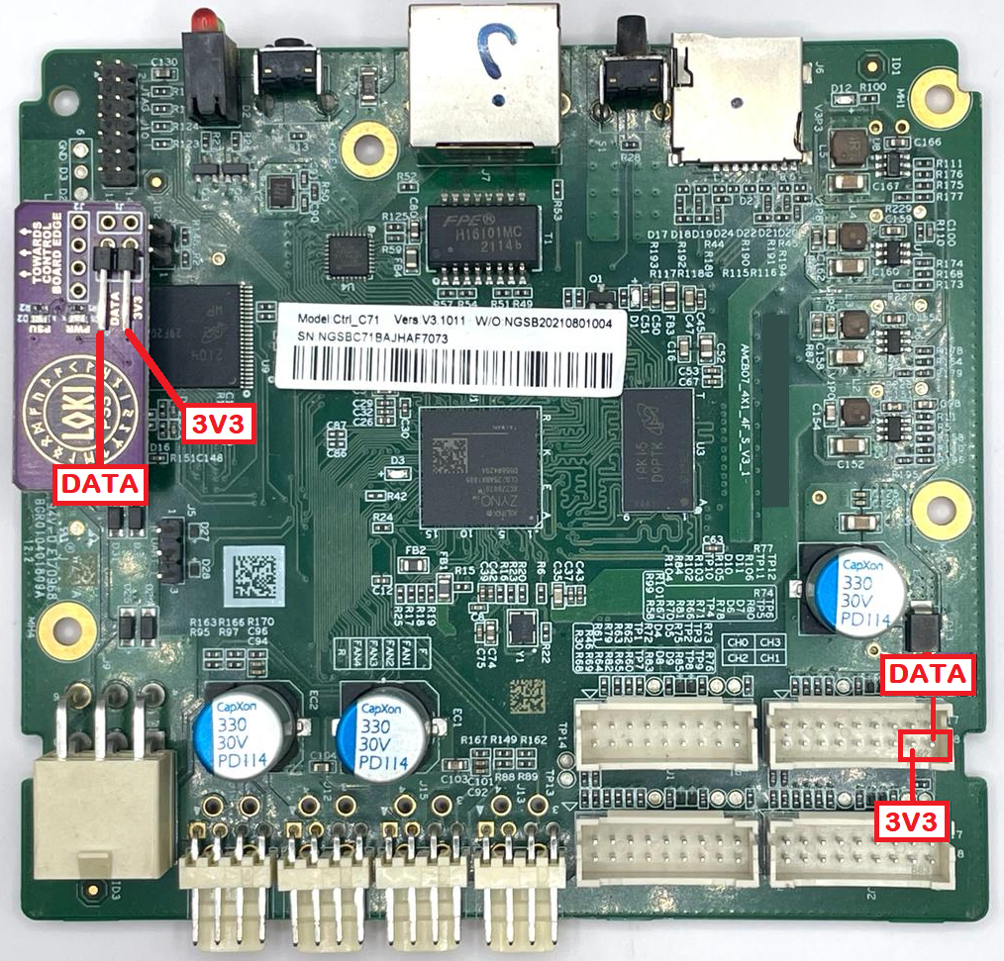

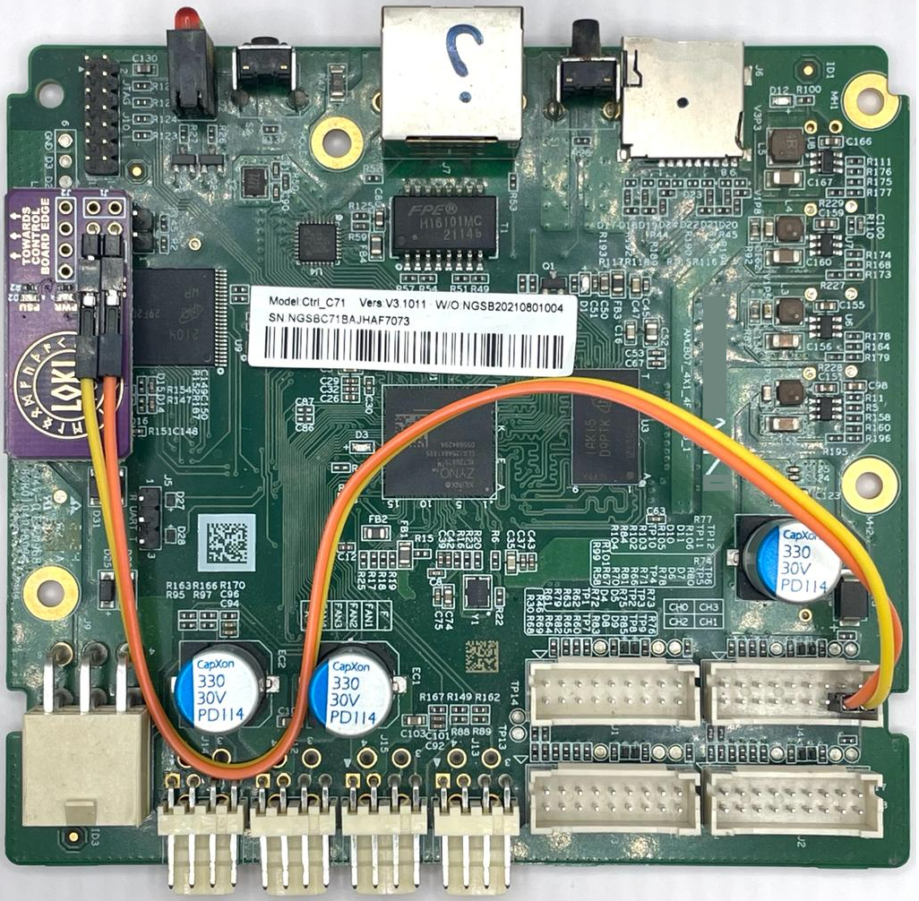

**Loki-AmLite:** Insert one of the “2-Pin Push-To-Install Header ” [11] into the two right holes of the control board’s 2.54mm debug header (outlined in red below) and connect the “3V3” pin of “LOKI-PSS Power (3.3V) and Data Conn.” [3] to the right pin of the “2-Pin Push-To-Install Header” [11] (see images below).

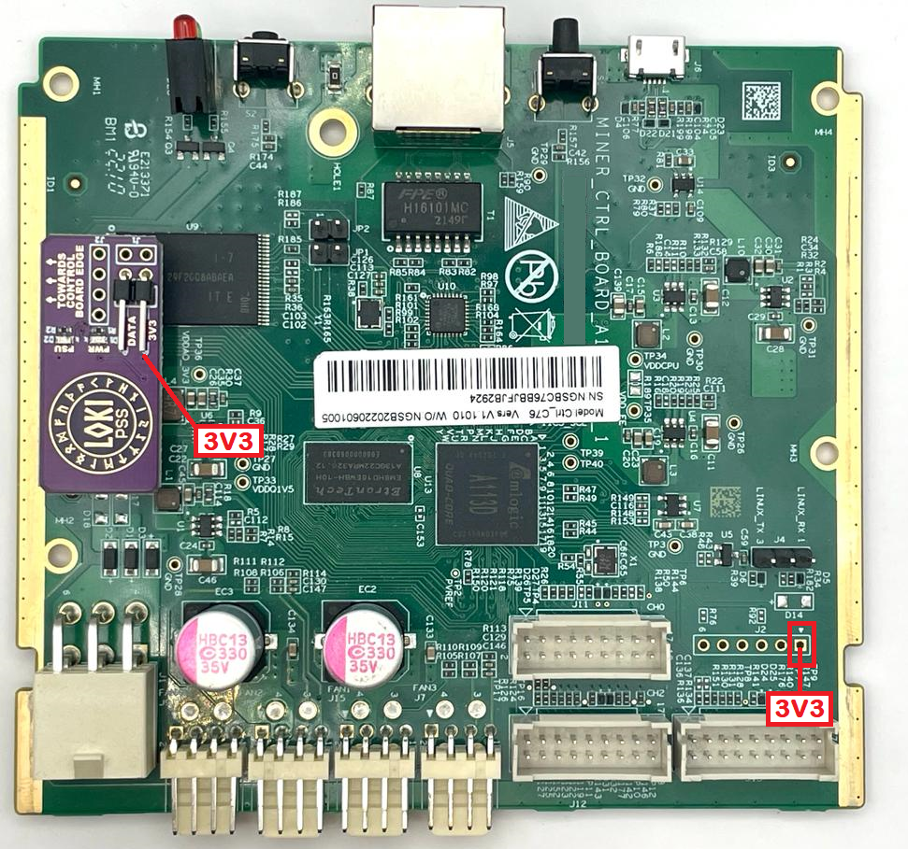

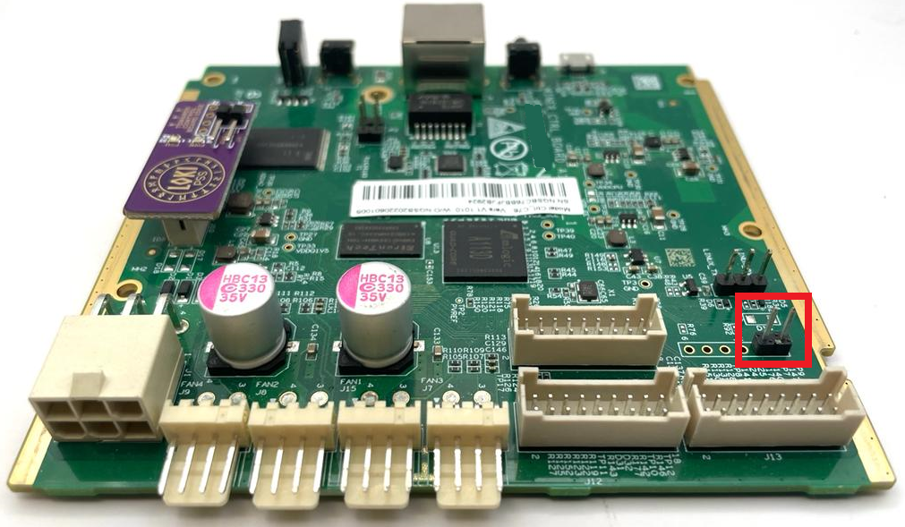

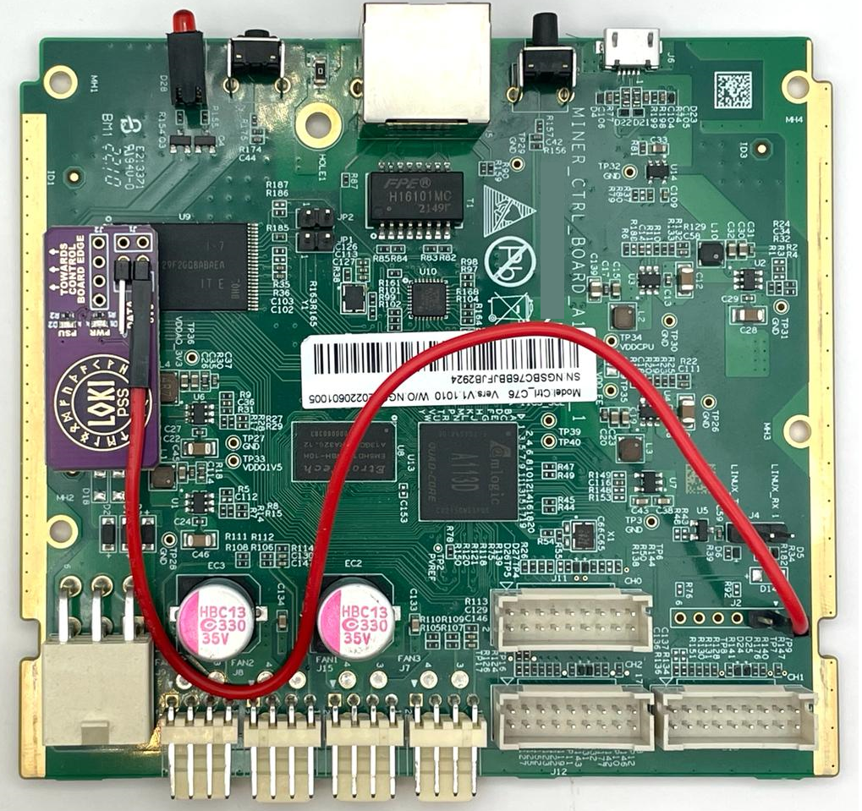

### 

### **Step 8**

**Loki-Duo:** Plug the ribbon cable coming from the hash board into the “Hash Board Ribbon Socket” [7]. Be sure to correctly align all socket pins with their corresponding connector holes before plugging in. The plastic tab on the ribbon cable connector should be facing in towards the control board and line up with the white rectangle printed on the LOKI-HBS board just above the “Hash Board Ribbon Socket” [7].

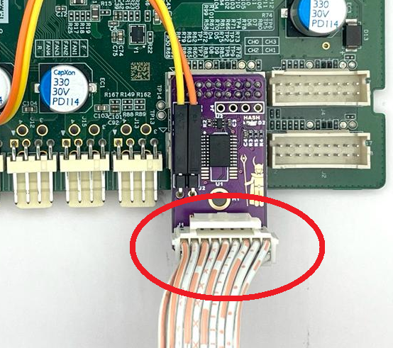

**Loki-Lite:** Skip

**Loki-AmLite:** Skip

### **Step 9**

Power up the mining equipment, observe LED indicator sequencing, and verify hash rate. Both the “LOKI-PSS Power Indicator LED” [1] and the “LOKI-HBS Power Indicator LED” [5] should light up immediately. Then the “PSU Spoofed Indicator LED” [2] will light up once PSU spoofing is successful. This may take 30 to 90 seconds. Finally, the “Hashing Indicator LED” [8] will light up when the control board has enabled hashing. This may take an additional 30 to 180 seconds. Note: if the “PSU Spoofed Indicator LED” [2] fails to light up, you may need to configure the LOKI-PSS to spoof a different PSU version. See the “Configuring LOKI-PSS” section below for more details.

# Configuring LOKI-PSS

By default, the LOKI-PSS spoofs the APW121215a power supply which is compatible with most Bitmain X19 miner configurations; however, there are some configurations that require the APW121215e power supply. If the miner fails to hash successfully with the Loki kit installed, try configuring LOKI-PSS to spoof a different PSU version. First, ensure that the miner is powered down. Second, locate the “J1” connector holes on the LOKI-PSS board (circled in red in the first image below). Third, install the “2-Pin Push-To-Install Header” [11] into the “J1” connector holes as shown in the second image below. Finally, connect the "2-Pin Jumper” [12] to the “2-Pin Push-To-Install Header” [11] as shown in the third image below.

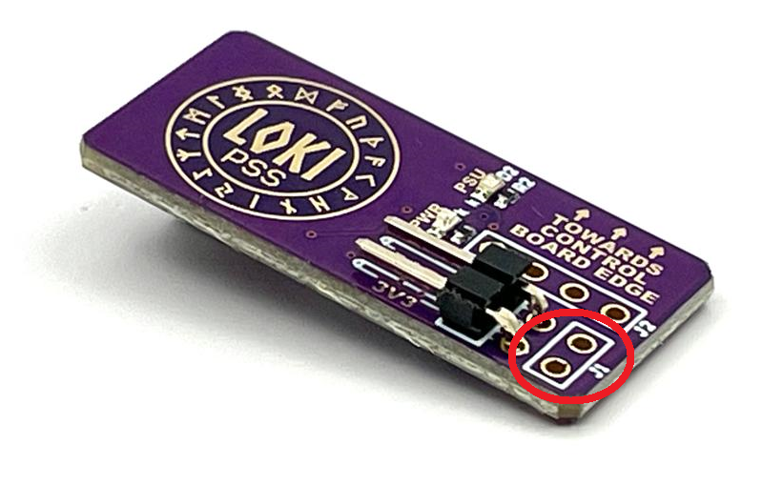

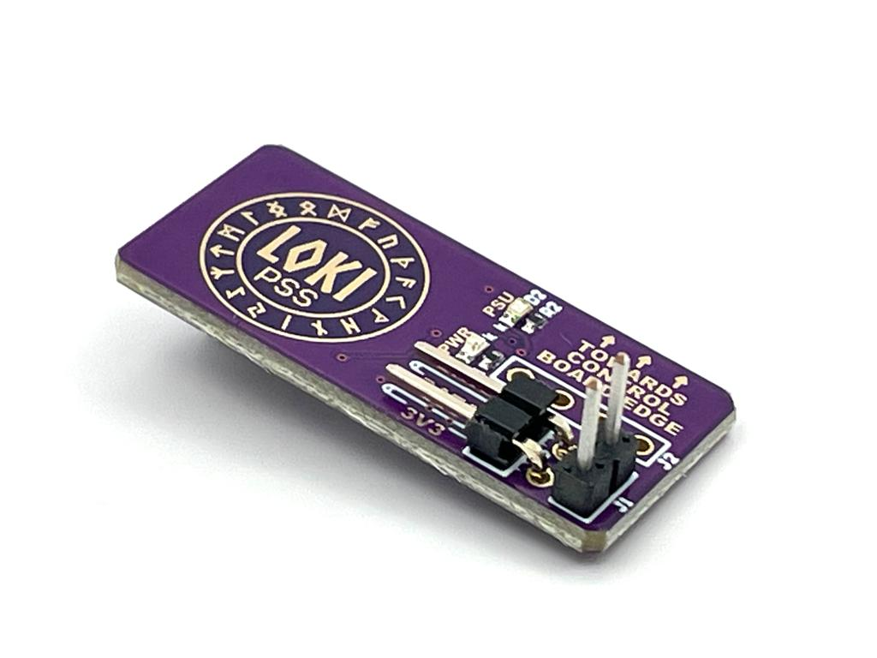 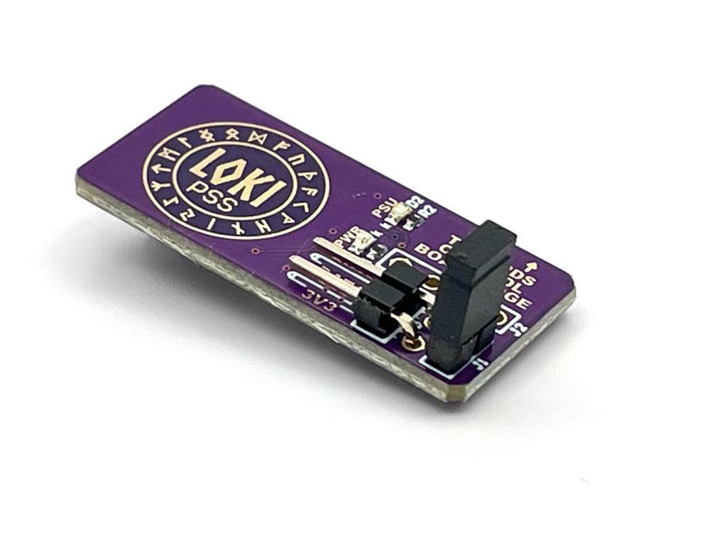

# 

# Selecting a Suitable Power Source

The Loki kit was designed to enable Bitmain’s Antminer X19 family to hash from any power source capable of supplying sufficient electrical current at suitable voltages. Careful consideration must be given when selecting an alternative power source. This section outlines several key parameters to consider.

### Electrical DC Current Draw and Resulting Power Requirements

The DC electrical current from the power supply to the hash board will vary widely (30 to 100 amps) depending on the specific hash board model, the DC operating voltage, and the selected hash frequency. For example, running an S19 76 chip hash board from 12V DC with very low clock speeds (less than 300 MHz) can result in the hash board drawing as little as 30 amps. Alternatively, running the same hash board from 15V DC with very high clock speeds (greater than 700 MHz) can result in the hash board drawing 100 amps or more.

A suitable power supply must be able to deliver the required electrical DC current at the desired operating voltage for the specific hashing configuration (HB variant, DC operating voltage, hashing frequency).

### Powering the Miner’s Control Board

The miner’s control board requires 12V DC to function properly. The alternative power source must be able to supply up to 15 amps at 12.15V DC to the control board's main power terminal (PCI connector). Additionally, the control board and hash board grounds must be electrically connected (at the same voltage potential).

### 

### High Current Hash Board Conductors

Care must be taken to properly size the electrical conductors that will be used to deliver electrical current from the alternative power supply to the hash board. SIZING THE ELECTRICAL CONDUCTORS TOO SMALL MAY RESULT IN OPEN FLAMES AND/OR DAMAGED EQUIPMENT.

Because the DC current requirements vary so widely from configuration to configuration, it’s not possible to prescribe a specific conductor size here. It’s recommended to determine the necessary current draw and then use an ampacity chart like the ones given below to determine the necessary gauge. Please note that the required wire gauge depends on the total DC current draw, the conductor material (copper, aluminum, brass, steel, etc.) and the conductor’s insulation temperature rating (if insulation is present).

A good starting point for the conductors is using the miner’s original high current bus bars. These have been designed to safely conduct the maximum amount of current the full miner (3 hash boards) will carry under normal operation. Alternatively, if the total current will be kept below 100A, the APW3++ wiring harness can be modified to work. See the linked guide in the appendix below.

#### Copper Conductor Ampacity Chart

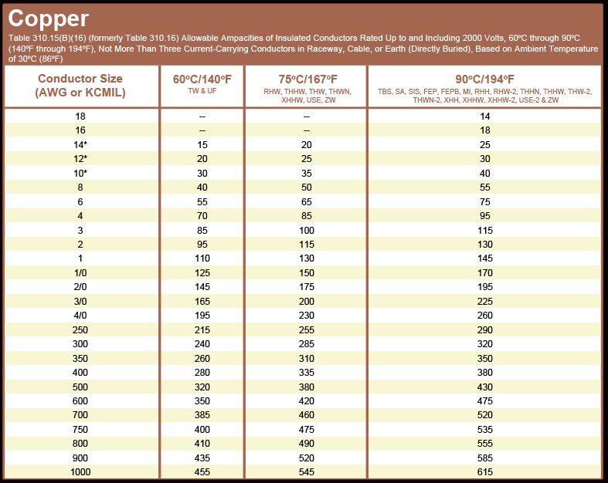

#### Aluminum Conductor Ampacity Chart

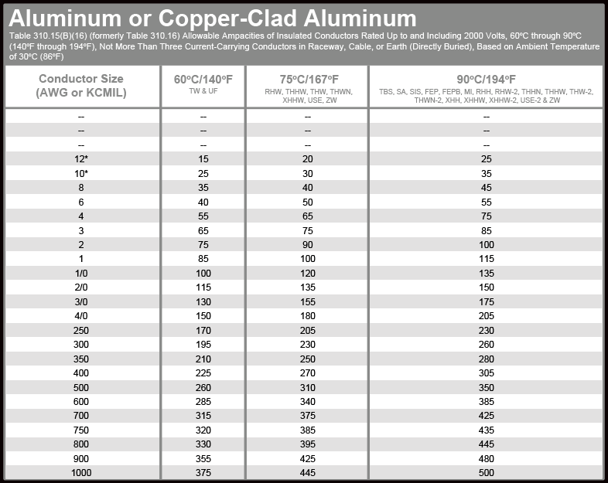

### 

# 

# Hashing from 120V AC

The Loki kit can be used to enable hashing from any generic 120V AC powered PSU capable of delivering sufficient DC current between 12V DC and 15V DC (see “Selecting a Suitable Power Source” above). When doing so, care must be taken to not overload the 120V AC circuit (circuit breaker, wiring, outlet, etc.).

Be sure to consider the power requirements of the mining equipment as well as all other electrical equipment on the same circuit. Also, keep in mind that no electrical circuit should be run continuously at its maximum current rating. DOING SO MAY RESULT IN CIRCUIT OVERLOAD AND/OR FIRE. For example, a 15 amp circuit should never be burdened with more than 12.5 amps continuously. If a Loki enabled power supply is running on a 15 amp circuit and drawing 1200 watts of power, only 1 mining rig should be powered from that circuit, and the sum total power draw of all other electrical equipment on that circuit (computers, lamps, etc.) should not be more than 300 watts. See the “Limiting Miner Power Draw” section below for ways to ensure that the miner does not pull more than 1500W.

# 

# Limiting Miner Power Draw

If powering a miner from a standard 120 volt, 15 amp outlet, care must be taken to limit the miner’s power draw to no more than 1500W MAX (1200W recommended). This section describes two options for doing so. Employing one or a combination of these steps is required to ensure a safe mining setup.

### Reducing Hash Voltage and Hash Frequency

Generally, the lower the hash voltage (voltage present at the hash board’s power terminals) and hash frequency, the lower the hash board’s power draw will be to a certain extent; however, lowering the hash voltage below the hash board’s minimum voltage requirement is not recommended. Doing so may cause ASIC chips on the hash board to fail causing poor efficiency and/or an increase in power consumption. See the “Hash Voltage, Hash Rate, and Miner Efficiency” section below for more details.

Powering multiple hash boards from the same 120V outlet will require BOTH running the hash boards at or close to their minimum hash voltage (approximately 12V for most X19 variants, but 14V for some) AND underclocking significantly with a hash frequency well below the stock hash frequency. The exact hash frequency that should be targeted for limited power draw varies widely between X19 variants. It is recommended to start low (50 - 100 MHz) and slowly work up until the desired power limit is reached. If using an autotune feature, it is recommended to tune to the lowest possible target power draw and then work up slowly until the desired power draw is reached. See “Autotuning with LoKi” below for more details.

As mentioned earlier, it is not recommended to use the Loki-AmLite kit with “NoPic” hash boards running Bitmain firmware when powering from a standard 120V outlet. This is because Bitmain requires a “full chain” (3 working hash boards) and doesn’t allow significant underclocking. These two factors combined will result in the miner drawing more than 1500W and overload the circuit.

It should be noted that while reducing hash frequency will lower the miner’s power consumption, it will also limit hash rate. If the goal is to maximize hash rate, the hash boards should be separated into multiple single hash board units with each one connected to different electrical circuit breakers.

### Remove Hash Boards

Standard, off-the-shelf X19 miners come with 3 hash boards. Each individual hash board can pull anywhere from as little as 350 W to as high as 2000 W based on the hash voltage, selected hash frequency, and to a small degree, the temperature of the hash board’s chips. Removing a single hash board will reduce the nominal power draw by a third. Removing two hash boards will reduce the nominal power draw by two-thirds. Removing one or more hash boards will allow the remaining hash board(s) to run at higher hash frequencies and increase hash rate without exceeding power limitations.

If hash boards are removed, care must be taken to manage proper airflow through the remaining hash board(s). Air must flow through the narrow channels of the hash board heatsink fins, not above or around them. Fill any cavities or gaps that could allow air to flow around the hash board’s heatsinks.

If one or more hash boards are removed to limit power draw, the hash boards that were removed can be paired with their own PSU, control board, Loki Kit, enclosure, and cooling equipment to create another 120V mining rig. If multiple rigs are being powered in the same location, care must be taken to spread the rigs out among available circuit breakers to avoid overloading circuit breakers.

# 

# Hash Voltage, Hash Rate, and Miner Efficiency

Each X19 family variant (S19, S19 Pro, S19j Pro, etc.) has an absolute minimum allowable hash voltage. For most variants, that minimum is just below 12V. For the 88 chip variant, that voltage is just below 14V. Going below the minimum voltage can cause ASIC chips on the hash board to fault.

If the goal is to maximize efficiency, it’s most likely to be reached by setting the voltage at or very close to the minimum allowable hash voltage and raising the hash frequency until just before the point where chips start to fault and efficiency degrades.

If instead the goal is to maximize hash rate without exceeding the maximum allowable power draw or sacrificing efficiency unnecessarily, hash voltage and hash frequency should be increased to their optimum operating points. The optimum hash frequency and hash voltage are dependent on one another. Generally, the higher the hash voltageis the higher the optimum hash frequency will be. Setting the hash frequency too high for a given hash voltage will result in chips faulting and, consequently, poor efficiency. On the other hand, setting the hash frequency too low for a given hash voltage will result in less than optimum efficiency. The graph below illustrates how hash voltage, hash rate, and miner efficiency are related. The graph is for illustrative purposes only and is not based on empirical data. It shows that for a given hash voltage, miner efficiency will improve with increased hash frequency until a certain point known as the optimum operating point. Increasing the hash frequency beyond the optimum operating point causes chips to fault.

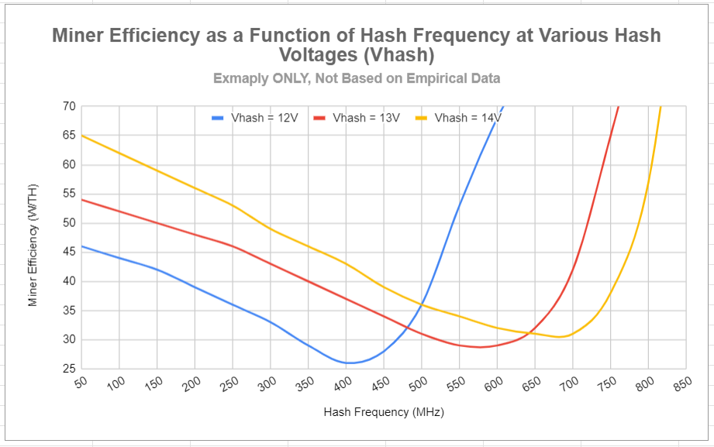

# 

# Autotuning with LoKi

Third party firmware like Braiins or Asic.to, that offer an autotuning feature, rely on being able to adjust hash voltage and hash frequency to find the most efficient operating point based on the selected power draw or hash rate. The Loki Kit doesn’t provide a way to adjust the output voltage of the PSU. Instead, it tricks the firmware into thinking that the voltage was adjusted to the requested value. Autotuning can still tune successfully so long as the actual hash voltage isn’t too far below the requested voltage. If the firmware is failing to autotune, the target power or target hash rate should be reduced until the requested hash voltage is sufficiently close to the actual hash voltage.

# APPENDIX

* [APW3++ Voltage Mod Guide](https://docs.google.com/document/d/1VI554zDH1LWUqoaOFHaL8ZwI2ZnO9AVQmK2ZTJ5TFtE/edit?usp=sharing)
* [APW3++ Wire Harness Modification Guide](https://docs.google.com/document/d/1hEh2XW7yJzJfub6O3e2CxQB2vN95M_UW0jz7VBk6UUI/edit?usp=sharing)